**Ideation Phase**

**Empathize & Discover**

|  |  |
| --- | --- |
| Date | 19 September 2022 |
| Team ID | PNT2022TMID50454 |
| Project Name | Project – Nutritiant Assistant Application |
| Maximum Marks | 4 Marks |

**Empathy Map Canvas:**

An empathy map is a simple, easy-to-digest visual that captures knowledge about a user’s behaviours and attitudes.

It is a useful tool to helps teams better understand their users.

Creating an effective solution requires understanding the true problem and the person who is experiencing it. The exercise of creating the map helps participants consider things from the user’s perspective along with his or her goals and challenges.

**Example:**

Reference: <https://www.mural.co/templates/empathy-map-canvas>

**Example: Food Ordering& Delivery Application**

Empathy Map Canvas

***Feels uncomfortable***

***Enrich the lives of elderly people with the modern days***

Starts a food diary

I couldn't find the food that I want

Will try to maintain the diet properly

***Looking for food that matches interest***

***Menu with healthy receipes***

***Does it working***

***People looking for alternatives and more practical ways overcoming thier disabilitty***

Gain insight and understanding on solving customer problems.

1

Build empathy and keep your focus on the user by putting yourself in their shoes.

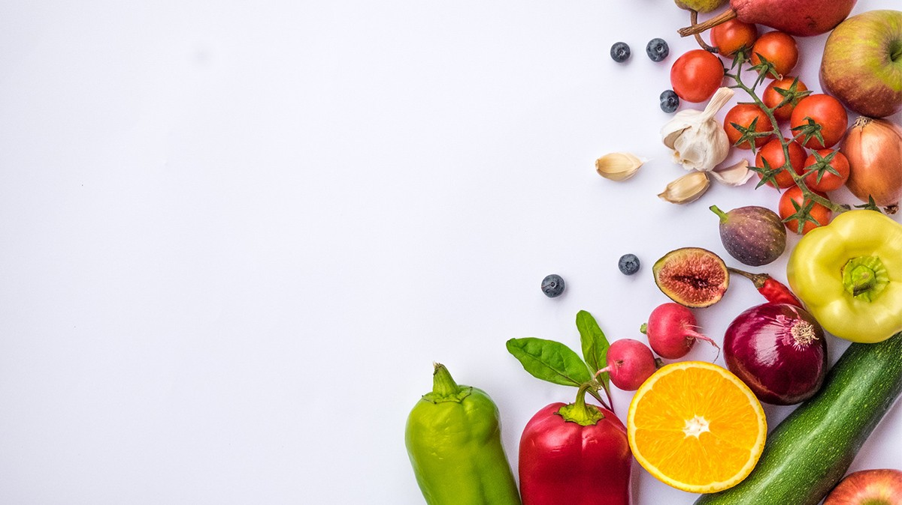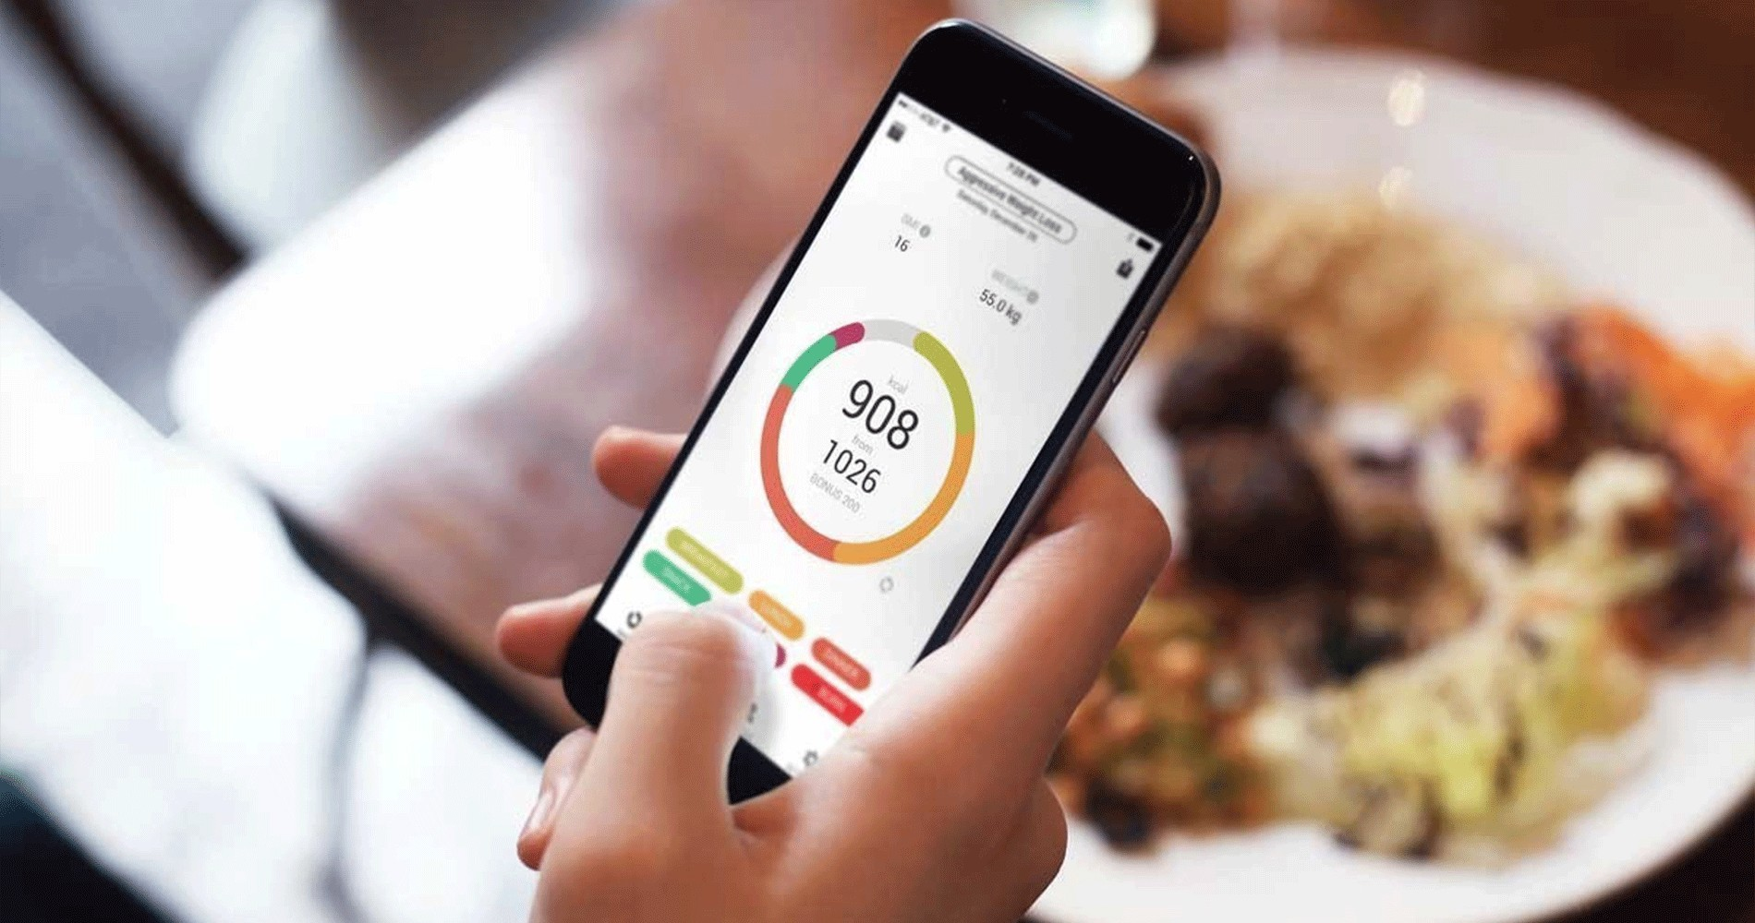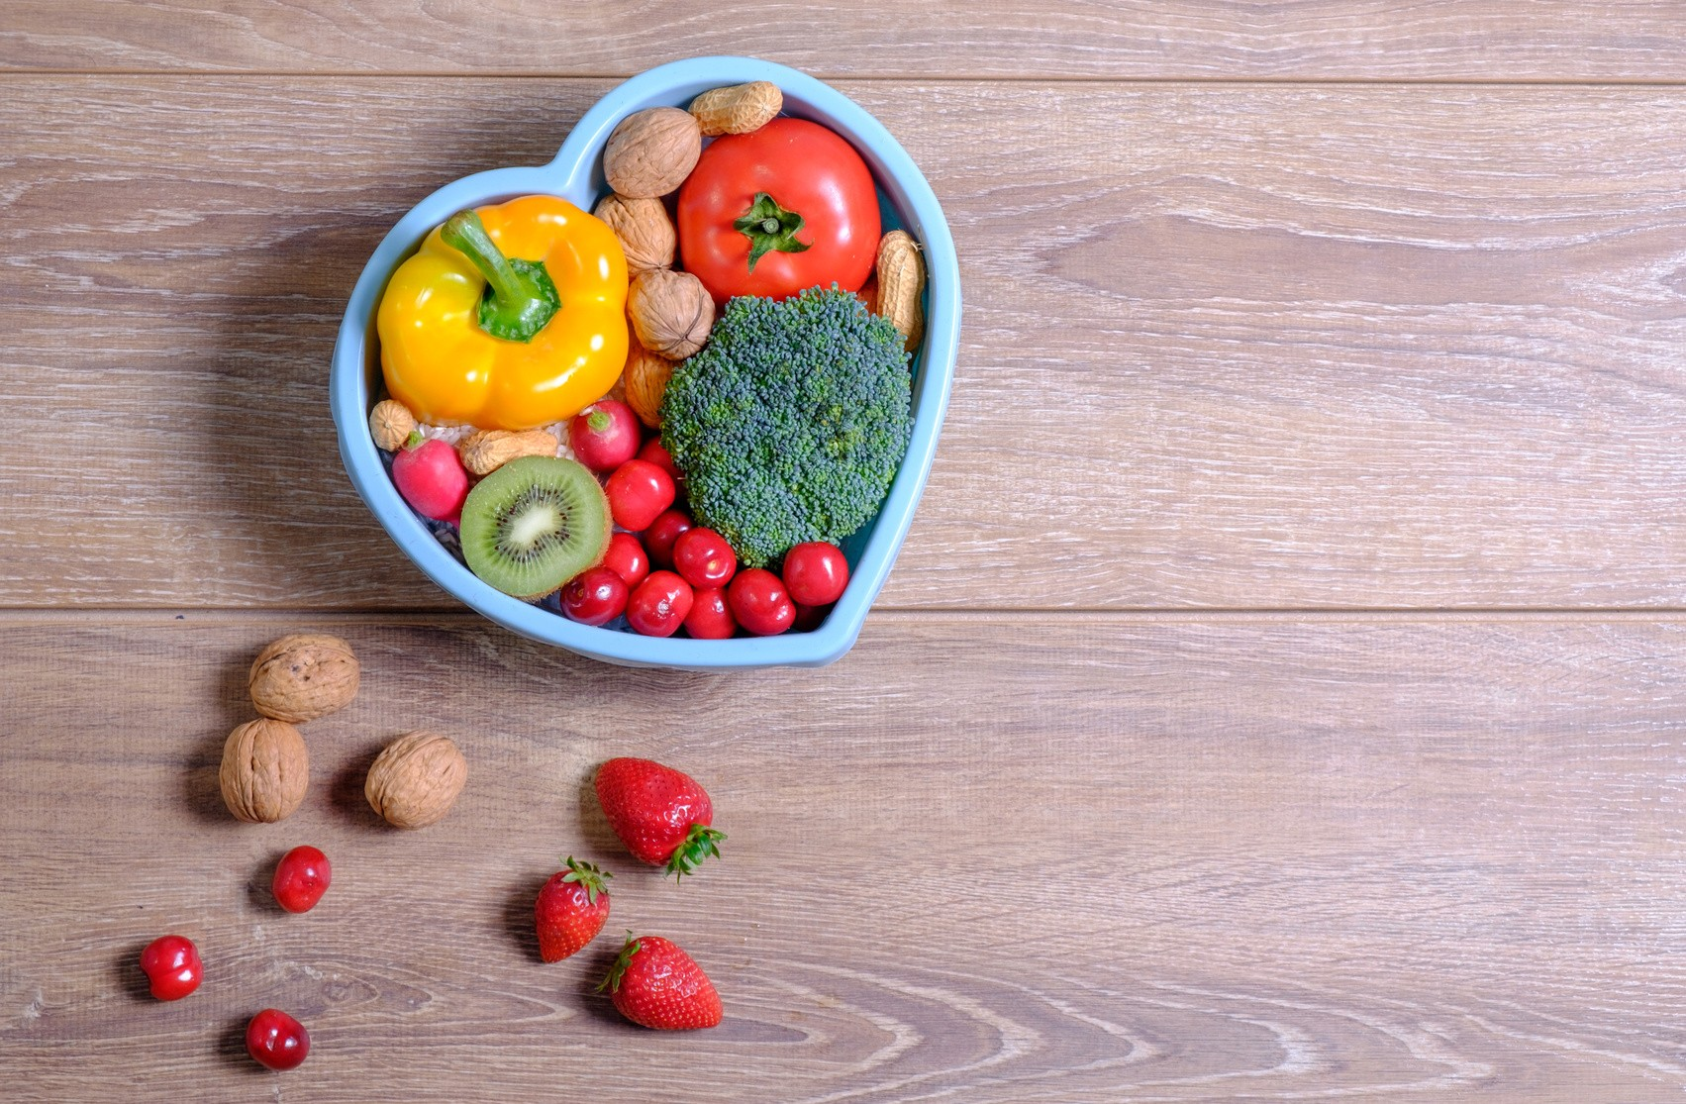

What should I eat today?

Doesn't want junk food

I need to plan my diet properly

***I want to burn calories but i don't know how to do thet***

***Share your feedback***

***Maintaining the calories level***

***Do you following the diet properly?***

***Difficult to find food interest***

***Hard to follow the diet***

***Feels healthy***

***Measures of success***